InnoSÜD
Exosomes for drug delivery

Institute for Applied Biotechnology (IAB)

Project leader | Prof. Dr. Kerstin Otte
Researcher | Christoph Keysberg
Financing | BMBF
Program
Partners | Ulm University
Duration | 2018 – 2022
Project description | Exosomes are small membrane bound extracellular vesicles produced by mammalian cell lines. They belong to the novel class of cell therapeutics and are currently developed as direct therapeutics or natural drug delivery vehicles. Exosomes may be used to deliver innovative drugs as therapeutic microRNAs (miRNAs). The current project aims in cooperation with Ulm University at the development of novel strategies to load, target and produce exosomal drug delivery vehicles.  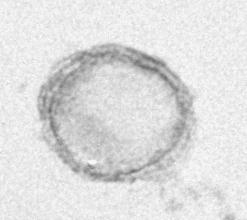  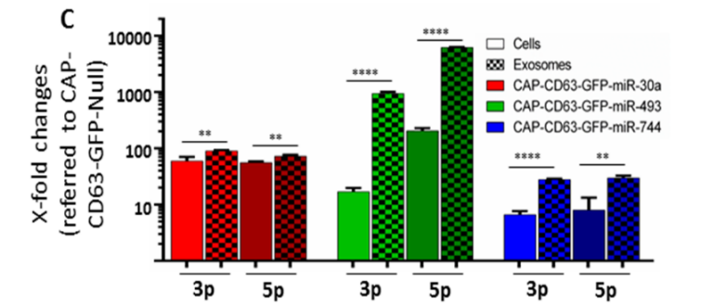  Exosomes: electron microscopy of exosome (100nm diameter) and analysis of miRNA loading by qPCR (after: Zeh et al, 2019, PLOS ONE)

